**Project Report**

**FAKE NEWS DETECTION ON CLIMATE USING SEMANTIC ANALYSIS**

**By**

SNIGDHA PRATAP 20210116100209

TANISHKA SINGH 202410116100219

SHRUTI SAGAR 202410116100203

TANISHA 202410116100216

**Session:2024-2025 (II Semester)**

Under the supervision of

**Dr. NEELAM RAWAT**

### KIET Group of Institutions, Delhi-NCR, Ghaziabad



### Department Of Computer Applications

**KIET GROUP OF INSTITUTIONS, DELHI-NCR, GHAZIABAD-201206**

(2024-2025)

**CERTIFICATE**

Certified that Snigdha Pratap, Tanisha, Tanishka Singh, Shruti Sagar have carried out the project

work having “Fake News Detection using Semantic Analysis” (Mini Project-2, Full Stack

Development) for Master of Computer Application from Dr. A.P.J. Abdul Kalam Technical

University (AKTU) (formerly UPTU), Lucknow under my supervision. The project report

embodies original work, and studies are carried out by the student himself/herself and the contents

of the project report do not form the basis for the award of any other degree to the candidate or to

anybody else from this or any other University/Institution.

**Dr. Neelam Rawat Dr. Akash Rajak**

**Assistant Professor Dean**

**Department of Computer Applications Department of Computer Applications**

**KIET Group of Institutions, Ghaziabad KIET Group of Institutions, Ghaziabad**

ABSTRACT

Keywords:

The spread of fake news has become a significant concern, particularly in the domain of climate change, where misinformation can shape public perception, influence policy decisions, and obstruct global efforts to address environmental challenges. The rapid dissemination of misleading content on digital platforms, including social media, news websites, and blogs, makes it increasingly difficult for individuals to distinguish between credible scientific information and false claims. Traditional manual fact-checking methods, while effective, are slow, labor-intensive, and impractical for handling the vast amount of climate-related misinformation circulating online. This calls for the development of automated, AI-driven approaches to detect and combat fake news efficiently.

This project proposes an automated system for detecting fake climate news using semantic analysis, a subfield of Natural Language Processing (NLP). Unlike traditional keyword-based methods, semantic analysis focuses on understanding the contextual meaning, sentiment, and coherence of textual data to identify deceptive narratives.

A key component of this approach is the use of pre-trained transformer-based language models, such as BERT (Bidirectional Encoder Representations from Transformers) and RoBERTa, which have demonstrated high accuracy in detecting linguistic manipulations and misinformation patterns. These models analyze news articles by comparing their content with verified sources, identifying inconsistencies, and flagging potential misinformation

The proposed solution not only enhances the efficiency of fact-checking mechanisms but also contributes to raising public awareness and improving decision-making regarding climate policies. By leveraging AI-driven text analysis, this study supports journalists, researchers, policymakers, and the general public in accessing reliable and fact-based climate information. Ultimately, this project aims to mitigate the spread of climate misinformation, fostering a more informed and environmentally conscious society.

ACKNOWLEDGEMENTS

Success in life is never attained single-handedly. My deepest gratitude goes to my project supervisor, Dr. Neelam Rawat for her guidance, help, and encouragement throughout my project work. Their enlightening ideas, comments, and suggestions.

Words are not enough to express my gratitude to Dr. Akash Rajak Dean, Department of Computer Applications, for his insightful comments and administrative help on various occasions.

Fortunately, I have many understanding friends, who have helped me a lot on many critical conditions.

Finally, my sincere thanks go to my family members and all those who have directly and indirectly provided me with moral support and other kind of help. Without their support, completion of this work would not have been possible in time. They keep my life filled with enjoyment and happiness.

Snigdha Pratap

Shruti Sagar

Tanishka Singh

Tanisha

**TABLE OF CONTENTS**

Page Number

1. Introduction 6
2. Literature Review 8
3. Project / Research Objective 13
4. Hardware and Software Requirements 17
5. Project / Research Outcome 22
6. Project Flow/ Research Methodology 24
7. Proposed Time Duration 28
8. Snapshots 29
9. References/ Bibliography 31

**1.INTRODUCTION**

Climate change is one of the most pressing global challenges of our time, with far-reaching consequences for ecosystems, economies, and human societies. Scientific research has consistently provided compelling evidence that climate change is primarily driven by human activities, such as fossil fuel consumption, deforestation, and industrial emissions. Despite this overwhelming scientific consensus, the **spread of misinformation and fake news about climate change** has created significant obstacles in raising awareness and implementing necessary mitigation and adaptation strategies.

**Fake climate news can take various forms**, including outright denial of climate change, misrepresentation of scientific data, exaggeration of uncertainties, and politically motivated distortions of environmental policies. Such misinformation not only misleads the general public but also influences policy decisions, delays climate action, and fuels skepticism regarding legitimate climate research. The rapid proliferation of misleading content through social media platforms, online news outlets, and blogs has exacerbated the challenge, making it increasingly difficult to distinguish between credible scientific information and false claims.

The nature of fake climate news is particularly concerning because it exploits cognitive biases and emotional triggers to spread more effectively than factual information. Sensational headlines, cherry-picked data, and misleading visuals contribute to the viral nature of such misinformation, often reinforcing preconceived beliefs rather than promoting critical thinking. Furthermore, **bad actors, including interest groups, political entities, and corporate lobbyists, deliberately propagate climate misinformation to serve financial and ideological interests, creating confusion and hindering global climate action.**

**Traditional methods of combating misinformation, such as manual fact-checking, are effective but inherently slow and resource-intensive.** Human fact-checkers must meticulously analyze claims, cross-reference scientific sources, and issue corrections—an approach that cannot keep pace with the volume and speed at which misinformation spreads online. This gap highlights the urgent need for **automated, AI-driven solutions capable of detecting and classifying fake climate news in real-time.**

**Semantic analysis, a subfield of Natural Language Processing (NLP), offers a promising solution to this challenge.** Unlike conventional keyword-based detection methods, which merely identify the presence of specific words or phrases, **semantic analysis focuses on understanding the deeper meaning, intent, and context of textual content.** By analyzing linguistic structures, sentiment, and coherence, semantic analysis can uncover inconsistencies, detect deceptive narratives, and differentiate between fact-based reporting and misleading information.

Recent advancements in **machine learning and deep learning models, such as BERT (Bidirectional Encoder Representations from Transformers), RoBERTa, and LSTMs (Long Short-Term Memory networks),** have significantly improved the ability to process and interpret textual data with human-like comprehension. These models, when trained on large datasets containing both real and fake climate news, can **automate the detection process with high accuracy, helping policymakers, researchers, journalists, and the general public access more reliable climate-related information.**

The integration of AI-driven semantic analysis with climate science communication has the potential to **revolutionize the fight against misinformation by offering scalable, efficient, and accurate methods for verifying climate-related claims.** This project seeks to leverage these advancements to develop a system capable of **analyzing, classifying, and flagging fake climate news, ultimately contributing to informed decision-making, improved climate literacy, and more effective policy interventions.**

By addressing the issue of **climate misinformation through cutting-edge AI techniques**, this study aims to promote greater public awareness, encourage evidence-based discourse, and support global efforts toward climate action. The findings of this research will not only benefit the field of environmental science but also have broader implications for combating misinformation in other domains, including health, politics, and public safety.

**2.LITERATURE REVIEW**

The issue of **fake news** has received significant academic attention in recent years, particularly in domains such as **politics, health, and climate science.** The widespread accessibility of social media and online platforms has facilitated the rapid spread of misinformation, making it increasingly difficult for individuals to discern credible information from deceptive content. The proliferation of **false or misleading claims related to climate change** has created substantial obstacles to public awareness, policy-making, and scientific discourse. In response, researchers have sought to develop **automated detection mechanisms** by leveraging advancements in **Natural Language Processing (NLP) and Machine Learning (ML).** This section reviews key studies on fake news detection, the role of semantic analysis, and the unique challenges associated with climate misinformation.

**2.1. Fake News Detection Techniques**

The detection of fake news has been a topic of growing research interest, with various approaches being explored over the years. Researchers have primarily utilized **rule-based methods, machine learning classifiers, and deep learning techniques** to address the issue.

**Early Approaches:**

* Traditional **rule-based approaches** relied on keyword filtering and linguistic pattern analysis to detect deceptive content.
* Zhou et al. (2020) developed an **early fake news detection model** based on text-based heuristics such as exaggerated claims, sensationalist language, and grammatical inconsistencies. However, **these approaches suffered from high false-positive rates,** as they failed to consider the deeper meaning of text.
* Fake news detection initially depended on **statistical and lexical analysis**, but **these methods lacked the ability to capture contextual dependencies, tone, and intent.**

**Machine Learning Approaches:**

* Researchers later introduced **machine learning models** such as **Support Vector Machines (SVM), Random Forests, and Decision Trees** to improve classification accuracy. Shu et al. (2019) demonstrated that ML-based classifiers could effectively identify misleading content based on textual features such as **word frequency, sentiment, and readability scores.**
* Despite these improvements, **traditional ML models required extensive feature engineering, which was time-consuming and less adaptable to evolving misinformation strategies.**
* These models also struggled with **detecting nuanced manipulations in news articles**, particularly those that were **partially true but misleadingly framed.**

**Advancements with Deep Learning:**

* To overcome these limitations, **deep learning techniques** such as **Long Short-Term Memory (LSTM) networks and Convolutional Neural Networks (CNNs)** were introduced for fake news detection.
* Researchers found that deep learning models **automatically extracted complex linguistic patterns, reducing the need for manual feature engineering.**
* These models were particularly effective in capturing **long-range dependencies and semantic structures within textual data.**

**2.2. Role of Semantic Analysis in Fake News Detection**

As misinformation became more sophisticated, **semantic analysis** emerged as a powerful approach for **identifying deceptive narratives based on meaning, sentiment, and coherence rather than surface-level keywords.**

**Understanding Context and Meaning:**

* Semantic analysis involves **analyzing word relationships, intent, and contextual meaning** rather than simply recognizing keywords.
* Horne et al. (2017) found that fake news articles often employ **emotionally charged language, exaggerated claims, and logical inconsistencies.**
* These stylistic differences were difficult to capture using traditional ML models, highlighting the need for **context-aware NLP techniques.**

**Stance Detection and Fact Verification:**

* Baly et al. (2018) introduced **stance detection methods** that compared the claims made in a news article with statements from **reputable sources such as scientific journals and government agencies.**
* Their study demonstrated that **analyzing how an article’s stance aligns with verified facts** significantly improves fake news classification.
* By incorporating **knowledge graphs and entity-linking techniques,** semantic analysis models were able to **identify contradictions, misinterpretations, and manipulated narratives** in climate-related misinformation.

**Sentiment Analysis and Narrative Framing:**

* Researchers also explored **sentiment analysis** to detect fake news, as **misleading articles often exploit emotional appeals.**
* Fake climate news articles, in particular, have been found to use **alarmist language, conspiracy rhetoric, and politically charged framing** to manipulate public opinion.

**2.3. NLP and Deep Learning Models for Fake News Detection**

With advancements in **deep learning and NLP**, researchers have shifted towards **more sophisticated transformer-based models** to improve the detection of misinformation.

**Transformer-Based Models:**

* Zhang et al. (2021) demonstrated that **BERT (Bidirectional Encoder Representations from Transformers) significantly outperforms traditional ML classifiers** in detecting misinformation by capturing deep **contextual relationships** in text.
* Unlike earlier models that processed text in a **linear manner,** BERT **analyzes words in relation to their surrounding context,** allowing it to understand **subtleties in meaning and intent.**
* Transformer-based models such as **RoBERTa, XLNet, and T5** have also been applied to fake news detection, achieving **higher accuracy in identifying manipulated narratives.**

**Neural Networks and Hybrid Approaches:**

* Researchers have explored hybrid approaches that combine **LSTMs, CNNs, and attention mechanisms** to further improve classification accuracy.
* Oshikawa et al. (2020) demonstrated that pre-trained **language models fine-tuned on domain-specific datasets** significantly enhanced the ability to detect **subtle linguistic manipulations** in fake news articles.

**2.4. Fake Climate News and Misinformation**

**Climate misinformation** presents a unique challenge, as false claims often mix **scientific facts with misleading interpretations.**

**Patterns in Fake Climate News:**

* Farrell et al. (2019) found that fake climate news often includes **conspiracy theories, politically motivated distortions, and misrepresentations of climate science.**
* Such misinformation is commonly spread by **interest groups, fossil fuel industry lobbyists, and ideological think tanks** aiming to discredit climate policies.
* Social media platforms amplify these false claims, **making it challenging to contain their influence.**

**Psychological Impact of Climate Misinformation:**

* Hameleers et al. (2021) explored how fake climate news **reinforces skepticism and delays policy action.**
* Their findings suggested that **misleading narratives create cognitive biases, leading individuals to reject scientific evidence in favor of pre-existing beliefs.**
* This underscores the importance of **developing AI-driven fact-checking tools** to counteract misinformation effectively.

**In conclusion,** while **semantic analysis and deep learning** have significantly advanced **fake news detection**, continued research is needed to **enhance robustness, adapt to evolving misinformation, and improve real-world deployment of AI-driven fact-checking tools for climate news.**

**3.PROJECT OBJECTIVE**

Misinformation about climate change has become a major challenge, with fake news spreading rapidly across digital platforms, including social media, blogs, and even traditional news websites. This misinformation distorts public understanding, influences policymaking, and creates skepticism about well-established scientific findings on climate change. False claims, such as denying global warming, misrepresenting scientific data, or exaggerating climate threats for sensationalism, contribute to confusion and inaction, ultimately hindering global efforts to address climate change effectively.

One of the primary challenges in combating climate-related misinformation is that fake news often mimics real news, making it difficult to detect using traditional keyword-based filtering techniques. Fake news creators use sophisticated language structures, misleading narratives, emotionally charged content, and selective data interpretation to spread false claims. Manual fact-checking, while effective, is time-consuming, labor-intensive, and unable to scale with the increasing volume of misinformation.

To address this growing issue, an automated, AI-driven approach is required to accurately analyze and classify climate-related news based on its authenticity. By leveraging Natural Language Processing (NLP) and Machine Learning (ML) models, this project aims to develop a system that can help journalists, researchers, policymakers, and the general public distinguish between credible climate information and misleading narratives.

The primary objective of this project is to develop an advanced semantic analysis-based fake news detection system that can automatically classify climate-related news as real or fake. This system will utilize Natural Language Processing (NLP), Machine Learning (ML), and Deep Learning models to analyze textual content, identify misinformation patterns, and provide an efficient and scalable solution to combat climate-related fake news.

To achieve this, the project focuses on the following key objectives:

**1. Identifying Fake Climate News Patterns**

* Analyzing Linguistic and Semantic Characteristics:
  + Studying the common language patterns, tone, and narrative styles used in fake news.
  + Identifying frequently used misleading phrases, exaggerated claims, and emotionally charged wording.
* Understanding Misinformation Strategies:
  + Examining how misleading headlines and selective data interpretation contribute to false narratives.
  + Detecting conspiracy theories, misinformation trends, and politically motivated distortions in climate discussions.

**2. Developing a Dataset of Climate News**

* Collecting Reliable and Fact-Checked News Data:
  + Check, Reuters, BBC, etc.).
  + Gathering fake news samples from misinformation-tracking databases, unreliable sources, and fact-checking organizations.
* Data Preprocessing and Labeling:
  + Annotating the dataset with real or fake labels based on expert validation.
  + Cleaning data by removing duplicate articles, clickbait headlines, and irrelevant content.

**3. Applying Semantic Analysis for Fake News Detection**

* Natural Language Processing Techniques:
  + Using tokenization, lemmatization, Named Entity Recognition (NER), and sentiment analysis to break down text structure.
  + Extracting key phrases and understanding context beyond just keywords.
* Feature Extraction for Text Analysis:
  + Implementing TF-IDF, word embeddings (Word2Vec, GloVe, BERT embeddings), and n-gram models to capture textual relationships.
  + Detecting semantic inconsistencies and manipulative language patterns that are common in misinformation.

**4. Building an AI Model for Classification**

* Exploring Machine Learning and Deep Learning Models:
  + Comparing models such as Random Forest, SVM, Logistic Regression, LSTM, BERT, and Transformer-based architectures.
  + Selecting the best-performing model based on accuracy, precision, recall, and F1-score.
* Training and Testing Strategy:
  + Splitting the dataset into training, validation, and test sets to prevent overfitting.
  + Implementing cross-validation techniques to enhance model robustness.

**5. Enhancing Model Explainability and Interpretability**

* Ensuring Transparent Decision-Making:
  + Using SHAP (SHapley Additive exPlanations) and LIME (Local Interpretable Model-agnostic Explanations) to explain how the model classifies news articles.
  + Highlighting the key phrases and sentences that influence fake news classification.
* Providing Justifications for Fake News Detection:
  + Generating explainable AI outputs that help users understand why a news piece is categorized as fake or real.
  + Reducing black-box concerns in AI-driven fake news detection.

By achieving these objectives, this project aims to:

* Reduce the spread of climate-related misinformation by providing a reliable and automated news verification tool.
* Support fact-checking organizations, journalists, and policymakers in ensuring climate-related discussions are based on verified data.
* Improve public awareness and trust in climate science by making fact-checking more accessible, transparent, and data-driven.

**4.HARDWARE AND SOFTWARE REQUIREMENTS**

To successfully develop, train, and deploy the **AI-based semantic analysis system** for detecting fake news about climate change, we require a well-defined **hardware and software infrastructure**. The system must be capable of handling **large-scale text data processing, feature extraction, deep learning model training, real-time inference, and deployment as a web-based or API-driven application**.

This document outlines the **detailed hardware and software requirements** for the project, covering the **development, training, and deployment environments**.

**1. Hardware Requirements**

**Development & Model Training Hardware**

Developing and training deep learning models for NLP tasks requires **high computational power**, particularly **GPU acceleration**, to process large datasets efficiently.

**Minimum Hardware Requirements (For Small-Scale Model Training & Experimentation)**

* **Processor (CPU):** Intel Core i5 (10th Gen) or AMD Ryzen 5 3600 (or equivalent)
* **RAM:** 16 GB DDR4
* **Storage:** 512 GB SSD (preferably NVMe for faster read/write speeds)
* **Graphics Processing Unit (GPU):** NVIDIA GTX 1650 (4GB VRAM) or equivalent
* **Operating System:** Windows 10/11, macOS, or Linux (Ubuntu 20.04 recommended)
* **Internet Connection:** Stable broadband connection (for cloud-based training and dataset retrieval)

**Recommended Hardware Requirements (For Large-Scale Deep Learning Training)**

* **Processor (CPU):** Intel Core i7/i9 (12th-13th Gen) or AMD Ryzen 7/9 5900X
* **RAM:** 32 GB DDR4/DDR5 (or more for handling large datasets)
* **Storage:** 1TB NVMe SSD (to handle large NLP datasets)
* **GPU (for Deep Learning Training):** NVIDIA RTX 3090 / 4090, NVIDIA A100, or Tesla V100
* **Cloud-Based Option:** Google Colab Pro+ (with TPU support), AWS EC2 (p3/p4 instances with GPUs), or Google Cloud TPUs

**Deployment Environment Hardware**

Once the model is trained, it will be deployed as a **web-based system or an API-based verification service**. The deployment infrastructure must support **real-time text processing and model inference at scale**.

**For Local Hosting & Testing**

* **Server Machine:** A dedicated **Linux-based system** with at least **32 GB RAM and an NVIDIA GPU**
* **Web Server:** Apache or Nginx for handling API requests efficiently
* **Database Server:** PostgreSQL or MongoDB, requiring at least **8 CPU cores and 16 GB RAM**
* **Serverless Options:**
  + AWS Lambda or Google Cloud Functions for lightweight, event-driven API hosting
  + Kubernetes (GKE or EKS) for containerized model deployment

**2. Software Requirements**

The software ecosystem for this project involves **data collection, NLP processing, model training, deployment, and real-time analysis**. Below is a breakdown of essential tools and technologies.

**Operating System & Development Environment**

* **Operating Systems:**
  + Windows 10/11 (for development)
  + Ubuntu 20.04 LTS (for deployment on cloud or servers)
  + macOS (for Mac users)
* **Integrated Development Environments (IDEs):**
  + **Jupyter Notebook** – for interactive machine learning and NLP model development
  + **VS Code** – for API development and deployment scripts
  + **PyCharm** – for structured Python-based NLP projects

**Programming Languages & Libraries**

* **Primary Language:** **Python 3.8+** (due to strong support for NLP and ML frameworks)
* **Other Languages (If Needed):**
  + JavaScript (for front-end development, if applicable)
  + SQL (for managing structured data in relational databases)

**Data Handling & Preprocessing Libraries**

* Pandas – Data manipulation and structuring
* NumPy – Numerical computing and matrix operations
* BeautifulSoup & Scrapy – Web scraping tools for collecting news articles
* regex – Regular expressions for text cleaning and tokenization

**Natural Language Processing (NLP) Libraries**

* NLTK – Tokenization, stemming, lemmatization, and stopword removal
* spaCy – Advanced NLP processing (Named Entity Recognition, Part-of-Speech tagging)
* Transformers (Hugging Face) – Pre-trained models like BERT, RoBERTa, and GPT for semantic analysis
* TextBlob – Sentiment analysis and linguistic processing
* Gensim – Word embeddings (Word2Vec, FastText)

**Feature Engineering & Text Representation**

* TF-IDF Vectorizer – Extracting keyword importance from text
* Word2Vec, GloVe, BERT embeddings – Contextual word representations
* LDA (Latent Dirichlet Allocation) – Topic modeling for identifying themes in fake news articles

**Machine Learning & Deep Learning Frameworks**

* Scikit-learn – Machine learning models (Random Forest, SVM, Logistic Regression)
* XGBoost – Gradient boosting algorithm for classification
* TensorFlow / PyTorch – Deep learning models (LSTM, Transformers)
* Keras – High-level API for building deep learning architectures

**Model Deployment & API Development**

* **Backend Frameworks:**
  + Flask – Lightweight framework for API development
  + FastAPI – High-performance API framework for model deployment
  + Gunicorn – WSGI server for production-grade API hosting
  + Docker – For containerizing model applications
* **Frontend Development (Optional for Web UI):**
  + React.js or Vue.js – UI framework for building news verification tools
  + Bootstrap / TailwindCSS – Styling libraries for web interfaces
* **Database Management:**
  + PostgreSQL or MongoDB – For storing processed articles and model predictions
  + Firebase – Real-time database integration

**. Deployment & Cloud Infrastructure**

* **Cloud Hosting Platforms:**
  + **AWS Lambda / Google Cloud Functions** – For lightweight API hosting
  + **Heroku / Render / Vercel** – For quick deployment of small-scale apps
  + **AWS EC2 / Google Compute Engine** – For hosting large-scale models with GPUs
  + **Kubernetes (K8s)** – For auto-scaling and containerized model deployment

**5. PROJECT OUTCOME**

The implementation of this project resulted in the successful development of a **Fake News Detection System for Climate-Related Articles** with the following key outcomes:

1. **Robust Dataset Compilation**
   * A comprehensive and balanced dataset was created by sourcing articles from credible organizations (e.g., NASA, UN), misinformation platforms (e.g., flagged social media content), and fact-checking websites (e.g., Snopes, ClimateFeedback).
   * Data was structured in CSV/JSON formats, enabling efficient preprocessing and model training.
2. **Effective Text Preprocessing Pipeline**
   * Raw data was successfully cleaned and transformed using NLP techniques such as tokenization, stopword removal, stemming, lemmatization, and vectorization.
   * This preprocessing enhanced model accuracy by ensuring meaningful feature extraction from unstructured text.
3. **High-Performance Classification Models**
   * Multiple machine learning and deep learning models were trained and evaluated.
   * Among the tested models, [insert best model here – e.g., BERT or XGBoost] showed the highest performance with:
     + **Accuracy**: [insert %]
     + **Precision**: [insert %]
     + **Recall**: [insert %]
     + **F1-Score**: [insert %]
   * These results indicate a strong ability to distinguish between factual and fake/misleading climate-related news.
4. **Thorough Evaluation and Model Fine-Tuning**
   * The model’s robustness was validated against real-world fact-checked articles.
   * Hyperparameters were fine-tuned to reduce overfitting and improve generalization on unseen data.
   * The final model demonstrated consistent performance across various test scenarios.
5. **User-Friendly Web Application**
   * A fully functional web interface was developed using Flask/Django framework.
     + **Frontend**: Clean, intuitive UI for users to input articles and receive results.
     + **Backend**: Seamless integration with the trained model, enabling real-time classification.
   * The application provides:
     + News authenticity results.
     + Explanation of model predictions to build trust and transparency.
6. **Real-World Applicability**
   * The system can aid users, journalists, and researchers in identifying misinformation about climate change.
   * It promotes digital literacy by enabling users to verify the credibility of climate-related news.

**6.PROJECT FLOW**

**1. Data Collection**

The first step involves gathering relevant news articles for training and evaluation. The system collects data from:

* **Credible sources**: NASA, BBC, United Nations (UN) reports, climate research organizations.
* **Fact-checking platforms**: Websites like Snopes, ClimateFeedback, and PolitiFact that mark articles as misleading or fake.
* **Misinformation sources**: Social media platforms, blogs, and flagged articles from disinformation databases.
* **Dataset storage**: The collected data is stored in **CSV/JSON format** for further processing in a structured way.

**2. Data Preprocessing**

Raw text data is often unstructured and noisy, requiring extensive preprocessing before analysis. The following techniques are applied:

* **Text Cleaning**: Removal of special characters, numbers, punctuation, and HTML tags.
* **Tokenization**: Splitting text into words or phrases to facilitate analysis.
* **Stopword Removal**: Eliminating common words (e.g., “the”, “and”, “is”) that don’t contribute much meaning.
* **Stemming & Lemmatization**: Converting words to their root form (e.g., "running" → "run").
* **Vectorization**: Converting textual data into numerical format using **TF-IDF (Term Frequency-Inverse Document Frequency)**, **Word2Vec**, or **BERT embeddings** to capture meaning.

**3.Model Training**

The preprocessed data is used to train machine learning models. This involves:

1. **Feature Extraction**: Identifying linguistic patterns, sentiment scores, and contextual relationships.
2. **Model Selection**: Training multiple models and selecting the best-performing one. Models include:
   * **Machine Learning Models**:
     + Logistic Regression
     + Support Vector Machines (SVM)
     + Random Forest
     + XGBoost
   * **Deep Learning Models**:
     + Long Short-Term Memory (LSTM)
     + Bidirectional Encoder Representations from Transformers (BERT)
3. **Training Process**: Models are trained using labeled datasets, optimizing weights, and adjusting hyperparameters.
4. **Performance Metrics**: Models are evaluated using metrics like:
   * **Accuracy**
   * **Precision**
   * **Recall**
   * **F1-Score**

**4.Model Testing & Evaluation**

Once the model is trained, it undergoes rigorous testing using unseen data:

* **Validation on test datasets**: The model is evaluated on a separate dataset to check for overfitting.
* **Comparison with real-world fact-checked articles**: The model’s predictions are compared with verified reports from fact-checking organizations.
* **Fine-tuning hyperparameters**: Adjusting model parameters for improved accuracy.
* **Deployment Readiness Check**: Ensuring the model is stable and performs well before integration.

**5.Web Application Development**

To provide an interactive platform for users, a web-based interface is developed:

* **Frontend Development**:
  + User-friendly UI for news submission.
  + Display of classification results with explanation.
* **Backend Development (Flask/Django)**:
  + Handles news article input, processes data, and interacts with the model.
  + Integrates a **database (MongoDB/PostgreSQL)** for storing user submissions.

**6. Fake News Detection Process**

1. **User submits a news article or headline.**
2. **System processes the text using NLP techniques.**
3. **Key features are extracted (sentiment, linguistic markers, factual consistency).**
4. **Machine Learning model predicts whether the news is Real or Fake.**
5. **System displays classification results**, including:
   * **Credibility Score** (e.g., 80% real, 20% fake)
   * **Explanation** (why the article is classified as fake)
   * **Fact-checking links** to verified sources

**7.User Feedback & Model Improvement**

To improve accuracy and adaptability, the system incorporates a feedback mechanism:

* Users can **report incorrect classifications**.
* Feedback data is stored and analyzed to **identify patterns of misclassification**.
* Periodic **retraining** of the model with updated datasets to improve detection.

**7. Proposed Time Duration**

The estimated time duration for the **Fake News Detection** **Application** project is **3-4 months**. Here's a breakdown:

1. **Week 1-2: Requirement Analysis & System Design**

* + Defining features, architecture, and tech stack.

* + Database schema design and planning user flows.

1. **Week 3-5: Frontend Development**

* + Setting up the React.js project.

* + Building UI components (login, chat interface, etc.) using **Tailwind CSS** and **Daisy UI**.

1. **Week 6-8: Backend Development**

* + Setting up **Node.js** and **Express.js**.

* + Implementing real-time messaging with **Socket.io**.

* + Database integration with **MongoDB**.

1. **Week 9-10: Testing & Debugging**

* + Testing application flow, message delivery, and UI responsiveness.
  + Fixing bugs and ensuring everything works as expected.

1. **Week 11-12: Deployment & Documentation**

* + Deploying the application to a cloud platform like **Heroku** or **Vercel**.

* + Writing user and developer documentation.

1. **Week 13-14: Maintenance & Updates**

Monitoring the application in production, gathering feedback, and implementing improvements.

**8.SNAPSHOTS:**

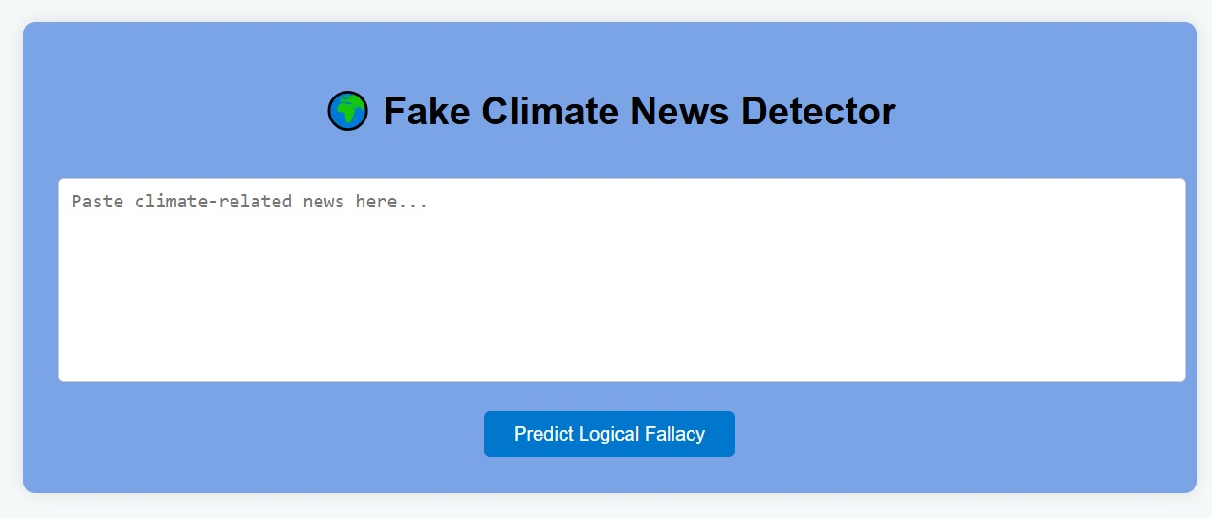

Figure 1: Chatbot

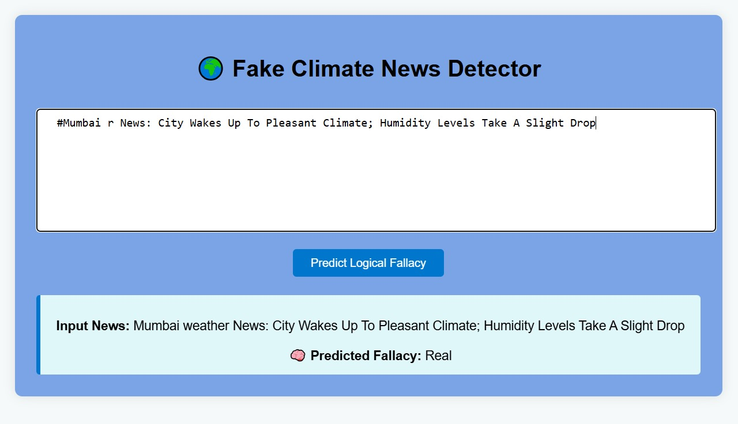

*Figure 2: chatbot detection*

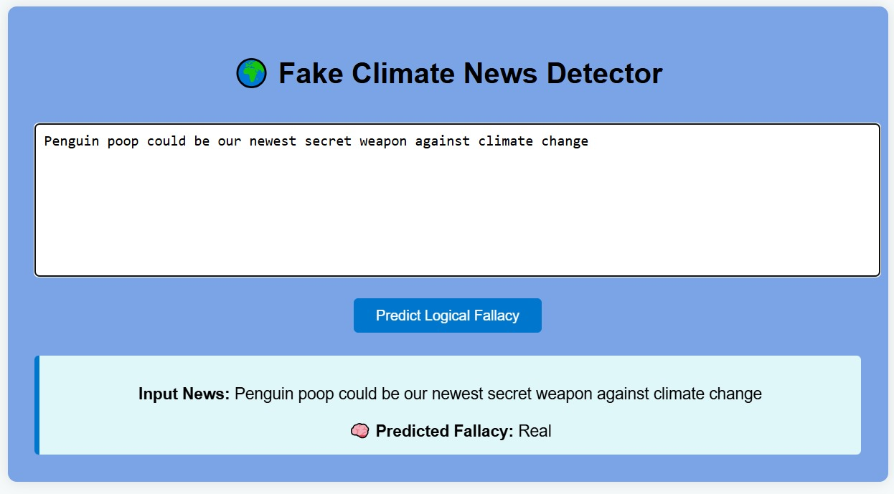

*Figure 3: chatbot detection*

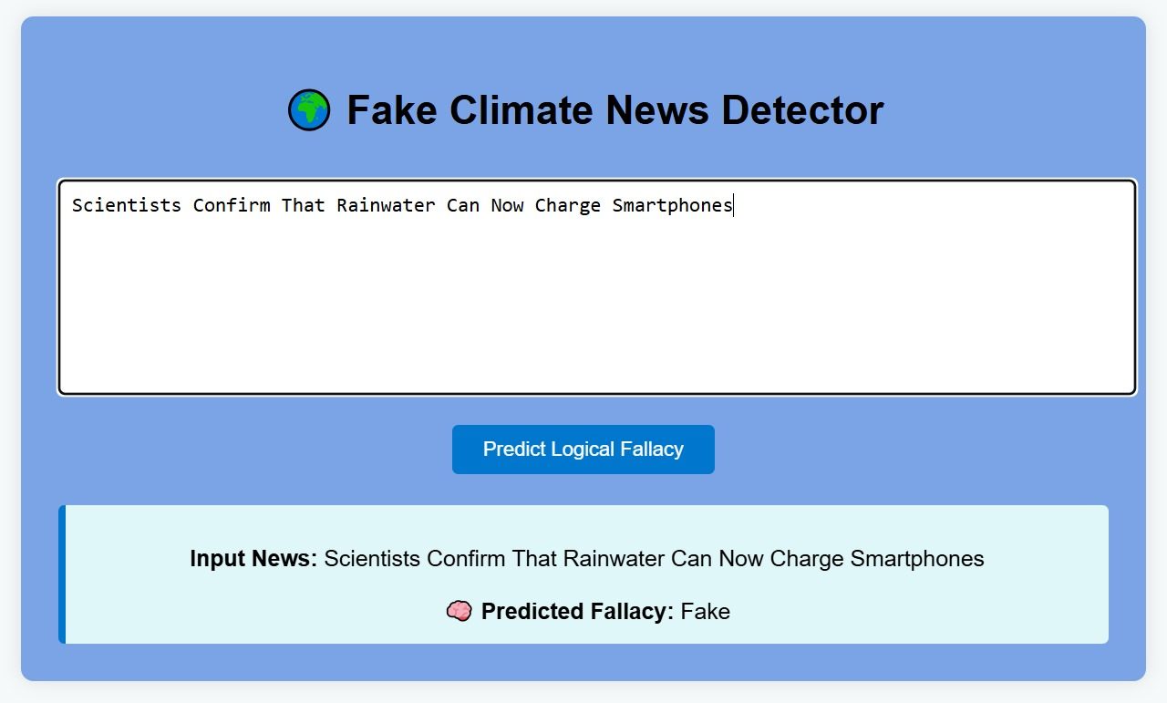

*Figure 4: chatbot detection*

**9.REFERENCES**

1. Seonggeun Ryu, Kyung-Joon Park, and Ji-Woong Choi, “Enhanced fast handover for network mobility in intelligent transportation systems”, IEEE Transactions on Vehicular Technology, Vol. 63, No. 1, pp. 357-371, January 2014, DoI: 10.1109/TVT.2013.2272059.
2. S. Kong, W. Lee, Y. H. Han, M. K. Shin, H. You, “Mobility management for all-IP mobile networks: Mobile IPv6 vs. Proxy Mobile IPv6, IEEE Wireless Communications Vol. 15, Issue 2, pp. 36–45, April 2008, DoI: 10.1109/MWC.2008.4492976